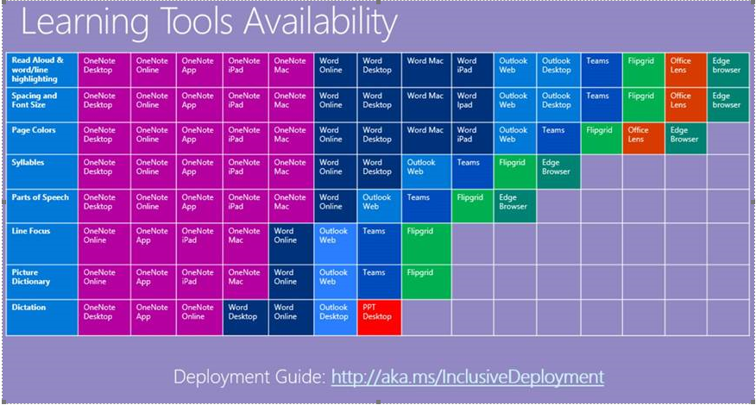
Periodic time line of what Microsoft products use which accessibility tools.

https://docs.microsoft.com/en-us/education/get-started/inclusive-classroom-it-admin

